*Florida International University*

*School of Computing and Information Sciences*

Software Engineering Focus

Feature Document

User Story ID 679

**Name:** Implement Notifications Page

**Team Member(s):** Leandro Gonzalez,Luis Herrnsdorf

**Project:** Smart Stormwater (Smart City System) 2.0

**Product Owner(s)**: Emilio Lopez

**Mentor(s)**:

**Instructor**: Masoud Sadjadi

**User Story Name:** Implement Notifications Page

* Description: As a User, I want to be able to view all notifications received, so that I am able to check the status of the devices assigned to me

Acceptance Criteria

* Users are able to reach the notifications page by clicking on the ‘Notifications’ tab on the side panel
* Notifications page shows all notifications for the devices the user has assigned
* Allow users to filter by device
* Allow users to sort notifications

**Use Case**

* Name: SeeNotifications001
* Actor: User
* Preconditions: User is logged in, user has device(s) assigned
* Description: Anywhere in the app, the user clicks on the “Notifications” tab on the side panel. User is redirected to the Notifications page, which contains a table displaying all notifications generated by the devices assigned to the user. User can click on the “Actions” button on the top right corner of the table, to sort the list by different fields, or to filter the list by one or more devices

**Use Case Diagram**

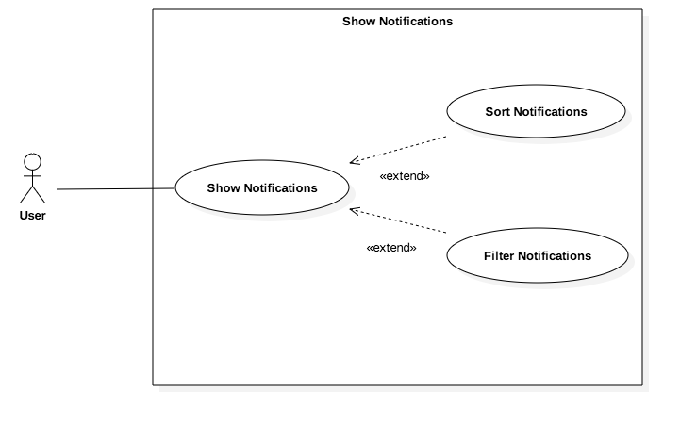

**Sequence Diagram**

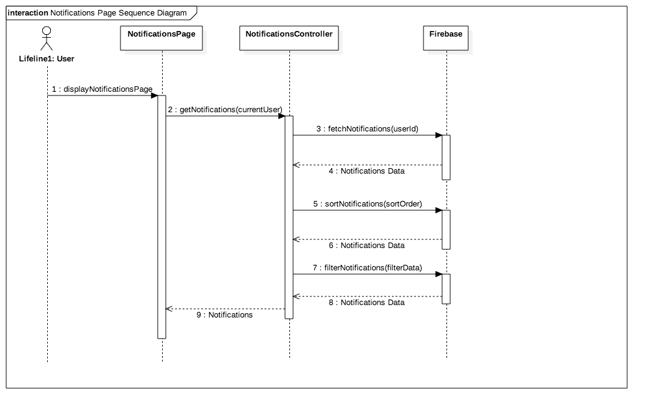

**Class Diagram**

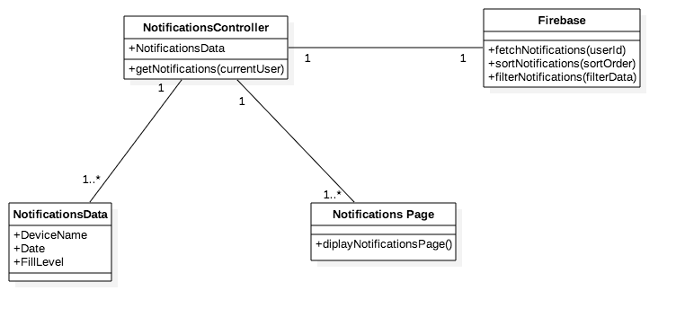

**Unit Test**

* Test case ID: CheckNotifications001
* Description/Summary of Test: User checks table containing his/her notifications, and sorts/filters the list
* Pre-condition: User is logged in, user has received notifications
* Expected Results: User is able to see all notifications, and to sort and filter
* Actual Result: User can check all his/her notifications and filter/sort the list
* Status (Fail/Pass): Pass

**Visual User Guide**

